**Project Design Phase-II**

**Data Flow Diagram & User Stories**

| Date | 10 March 2025 |
| --- | --- |
| Team ID | SWTID1741351150152139 |
| Project Name | **CookBook** |
| Maximum Marks | 4 Marks |

| ARTHI E | arthi.cs2225@gmail.com |
| --- | --- |
| DHARSHINI T | dharshini.cs2225@gmail.com |
| HARINI PRIYA R | harinipriya.cs2225@gmail.com |
| SANDHIYA S | sandhiya01022005@gmai.com |
| LAVANYA P | lavanya.cs2225@gmail.com |

**Data Flow Diagrams:**

A Data Flow Diagram (DFD) is a traditional visual representation of the information flows within a system. A neat and clear DFD can depict the right amount of the system requirement graphically. It shows how data enters and leaves the system, what changes the information, and where data is stored.

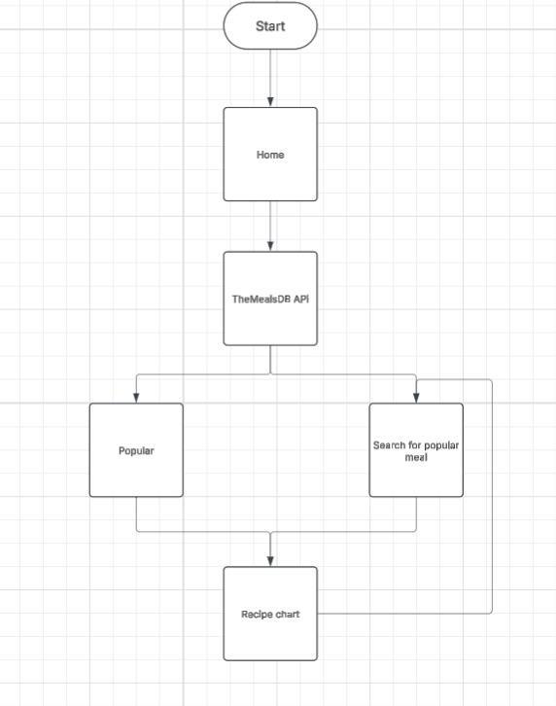

**User Stories**

Use the below template to list all the user stories for the product.

| **User Type** | **User Story Number** | **User Story / Task** | **Acceptance criteria** | **Priority** | **Release** |
| --- | --- | --- | --- | --- | --- |
| Customer  (Web user) | USN-1 | As a user, I can search for recipes, view detailed recipe instructions | I can access my account / dashboard | High | Sprint-1 |
| Customer  (Web user) | USN-2 | As a user, I can upload recipe images and manage my recipes | I can view uploaded images | High | Sprint-1 |
| Customer  (Web user) | USN-3 | As a user, I can receive personalized recipe recommendations based on preferences | I can register & access the dashboard with Google Login | Low | Sprint-2 |